RE Bridging Document – Introductory Sessions Information

The following information is intended to help with running with Introductory Sessions for the Religious Education Bridging Document. There are three PowerPoints in total.

Session 1 - What is the REBD; Relationship with the NZ RE Curriculum
Preperation
- Ask all participants to have an electronic copy of the REBD on their devices so they can look at parts during the gathering.
- Provide copies, enough for at least one between two, of:
  - The Foreword of the “Religious Education Curriculum Statement for Catholic Primary Schools in Aotearoa New Zealand”
    - Included in page 2 of this information. However, it would be good to have some of your copies of the 1996 Religious Education Curriculum Statement at the gathering in case people want to look more closely at other sections.
- Provide some large sheets of paper & pens for small groups to record thinking during the session.

Session 2 - Delving Deeper. Catholic Schools; what is RE; & Spirituality
Preperation
- Ask all participants to have an electronic copy of the REBD on their devices so they can look at parts during the gathering.

Session 3 – Considering our learners, assessment & Applying Pedagogy
Preperation
- Ask all participants to have an electronic copy of the REBD on their devices so they can look at parts during the gathering.
- There’s a bit of audio in the powerpoint so have some speakers set up.
  - Slide 8 is organised to run on the next mouse-click so you can still use a ‘clicker’ and won’t need a mouse.
- Have some copies of page 36 – Considering our learners – copied off, preferably blown up to A3, for school groups to use.
  - Pens as required.
- Have a white board, or large sheets to record the large group PMI feedback from the pedagogy session.

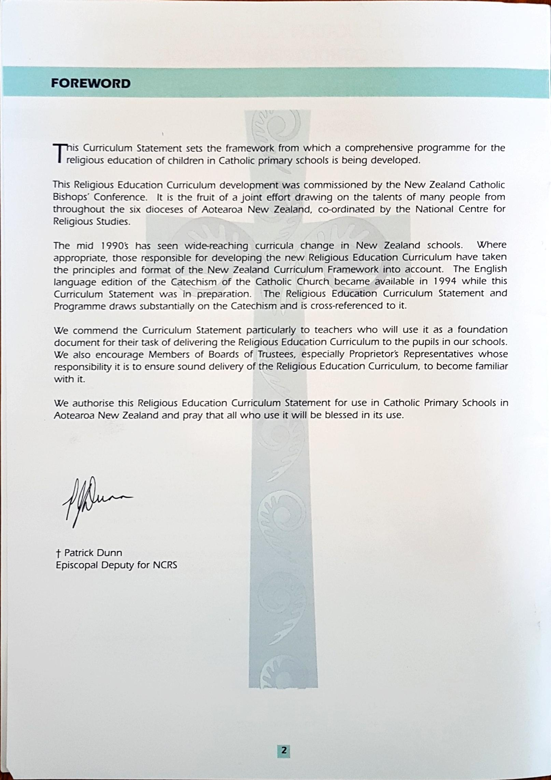
From the 1996 Religious Education Curriculum Statement for Catholic Primary Schools
in Aotearoa New Zealand.

